**ARUNACHALA COLLEGE OF ENGINEERING FOR WOMEN**

**DEPARTMENT OF COMPUTER SCIENCE AND ENGINEERING**

**CUSTOMER CARE REGISTRY**

# TECHNOLOGY ARCHITECTURE

|  |  |
| --- | --- |
| **DATE** | 1 November 2022 |
| **TEAM ID** | PNT2022TMID34000 |
| **PRIJECT NAME** | Customer Care Registry |

**PROJECT DESIGN PHASE-2**

## TECHNOLOGY ARCHITECTURE

**TECHNOLOGY ARCHITECTURE:**

* Technology architecture deals with the deployment of application components on technology components.
* A standard set of predefined technology components is provided in order to represent servers, network, workstations, and so on.

**ROLE OF TECHNOLOGY ARCHITECTURE:**

* A technology architect is a leadership position that oversees the use and productivity of technology for an agency.
* They often serve as project managers, where they organize timelines to develop new applications and evaluate the performance of IT associates under their supervision.

**TECHNOLOGY ARCHITECTURE DIAGRAM:**

* An architectural diagram is a diagram of a system that is used to abstract the overall outline of the software system and the relationships, constraints, and boundaries between components.
* It is an important tool as it provides an overall view of the physical deployment of the software system and its evolution roadmap.

**TECHNOLOGY ARCHITECTURE DIAGRAM [CUSTOMER CARE REGISTRY]:**

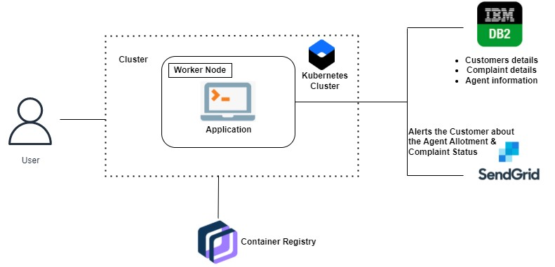

## TABLE-1 : COMPONENTS AND TECHNOLOGIES

|  |  |  |  |
| --- | --- | --- | --- |
| **S.NO** | **COMPONENT** | **DESCRIPTION** | **TECHNOLOGY** |
| 1. | User Interface | The user interacts with the Web UI  (Login form, Signup form, Dashboard, Ticket status, Forget password page), chat bots (IBM Watson Assistant) | HTML, CSS,  JavaScript |
| 2. | Login Logic | The customer / agent enters their email and password, and their respective roles and click on the Login button. The data entered is collected and checked and verified | HTML forms,  Python, SQL, IBM  DB2 |

|  |  |  |  |
| --- | --- | --- | --- |
|  |  | for the corresponding entry in the IBM DB2 database. If everything is correspondence with the data in the  IBM DB2, customer / agent logs in. |  |
| 3. | Register Logic | Customers registers in the application with their name, email, mobile number and password. The data entered is collected and stored in the IBM DB2 database. Once it is done, the customer is redirected to the Login page. | HTML forms,  Python, SQL, IBM  DB2 |
| 4. | Agent Creation Logic | Admin creates an agent with the following credentials. Name, email, mobile, gender, username, password. The data is collected and stored in the database. | HTML forms,  Python, SQL, IBM  DB2 |
| 5. | Ticket Creation Logic | Customer creates a new ticket in his dashboard, with the detailed description of his/her query (max of 150 characters). This ticket is then stored in the database with a unique ID and a foreign key as the customer ID. | HTML forms,  Python, SQL, IBM  DB2 |
| 6. | Agent  Assigning  Logic | Agent sees all the newly created tickets in his/her dashboard. Agent then goes on to assign an agent for  each ticket. The ticket status is updated in the IBM DB2 and then the customer who raised that ticket is notified through mail that as agent has been assigned. | HTML forms,  Python, SQL, IBM  DB2, SendGrid |
| 7. | Cloud Database | Stores all the details. Customer details, Agent details, Admin details, Ticket details. | IBM DB2 database |
| 8. | Object Storage | Stores some images in buckets. Used to display static images in the application | IBM Cloud Object Storage |
| 9. | Chatbot  (External API) | Used to guide customers, agents while logging in. Also, helps the customers while raising a ticket. Agents / Customers can interact with the chatbot and act right. | IBM Watson Assistant API |
| 10. | SendGrid  (External API) | Used to notify the customers that an agent has been assigned for their raised ticket. Also, for the agents and customers while resetting their passwords. | SendGrid API, Python |

## TABLE-2 : APPLICATION CHARACTERSTICS

|  |  |  |  |
| --- | --- | --- | --- |
| **S.NO** | **CHARACTERSTICS** | **DESCRIPTION** | **TECHNOLOGY** |
| 1. | Open-Source Frameworks | Flask micro-web framework | Python, Jinja, WSGI |
| 2. | Security  Implementations | All passwords are encrypted. Access control is implemented using Login Manager in Flask.  Roles are defined in the SQL to prevent data manipulation and access | SHA-256  encryption, Flask,  SQL |
| 3. | Scalable Architecture | Justify the scalability of architecture (3 – tier, Microservices) | supports higher workloads without any fundamental changes to it. |
| 4. | Availability | Justify the availability of application (e.g. use of load balancers, distributed servers etc.) | High availability enables your IT infrastructure to continue functioning even when some of its components fail. |
| 5. | Performance | Design consideration for the performance of the application (number of requests per sec, use of  Cache, use of CDN’s) etc. | Performance technology, therefore, is a field of practice that uses various tools, processes, and ideas in a scientific, systematic manner to improve the desired outcomes of individuals and organizations. |